SVKM’s Dwarkadas J. Sanghvi College of Engineering
Application Number: - 202421078054
Sheet 1 of 5 Total number of Sheets - 5

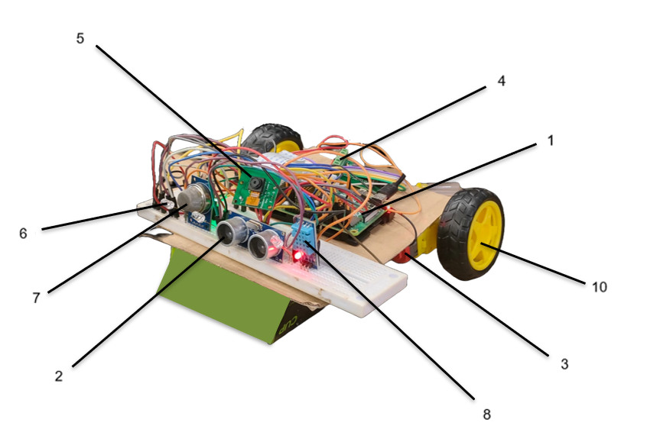

Figure 1

SVKM’s Dwarkadas J. Sanghvi College of Engineering
Applicant
SVKM’s Dwarkadas J. Sanghvi College of Engineering
Application Number: - 202421078054
Sheet 2 of 5 Total number of Sheets - 5

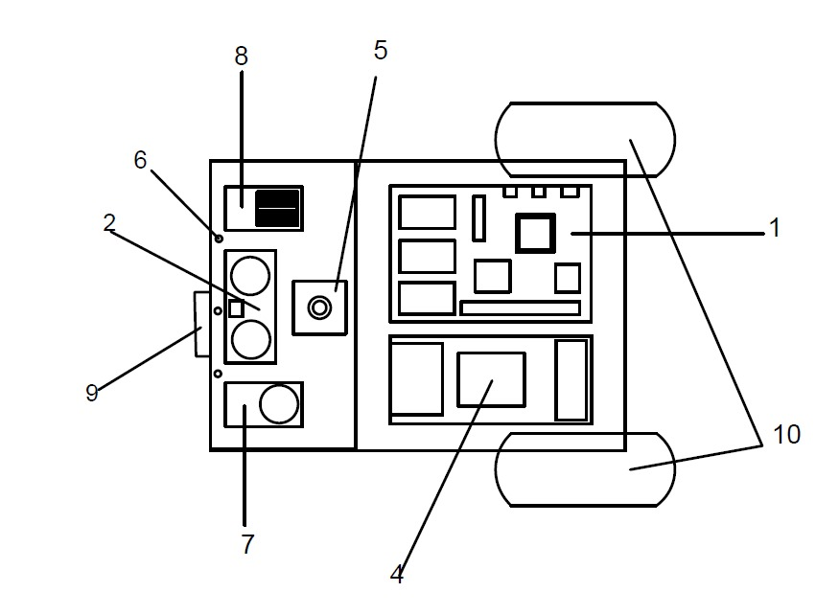
Figure 2

SVKM’s Dwarkadas J. Sanghvi College of Engineering
Applicant
SVKM’s Dwarkadas J. Sanghvi College of Engineering
Application Number: - 202421078054
Sheet 3 of 5 Total number of Sheets - 5

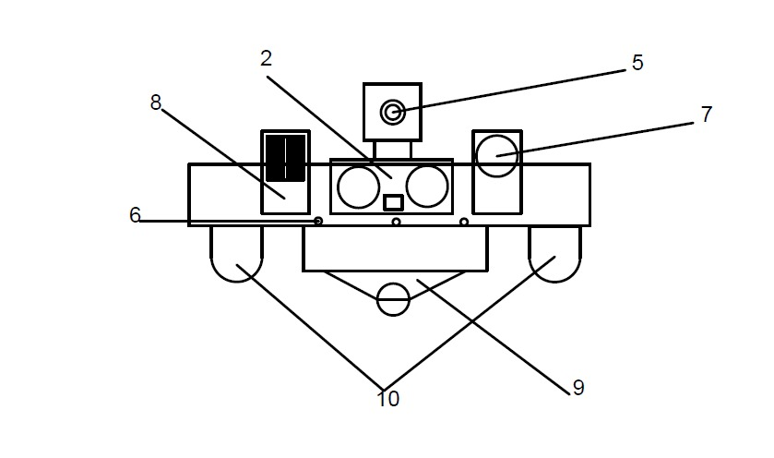
Figure 3

SVKM’s Dwarkadas J. Sanghvi College of Engineering
Applicant
SVKM’s Dwarkadas J. Sanghvi College of Engineering
Application Number: - 202421078054
Sheet 4 of 5 Total number of Sheets - 5

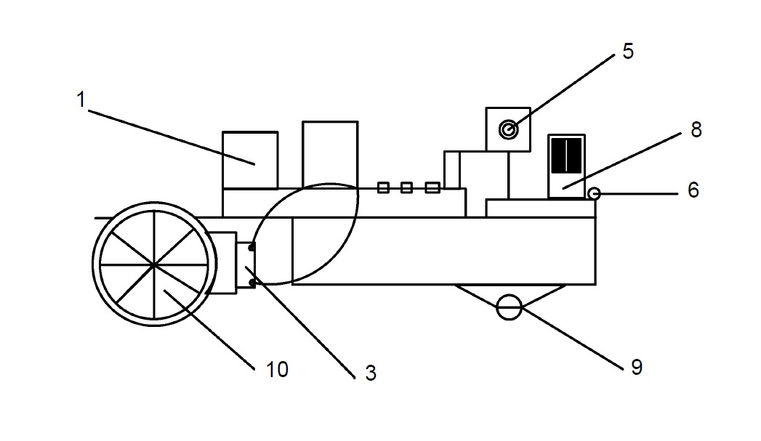
Figure 4

SVKM’s Dwarkadas J. Sanghvi College of Engineering
Applicant
SVKM’s Dwarkadas J. Sanghvi College of Engineering
Application Number: - 202421078054
Sheet 5 of 5 Total number of Sheets - 5

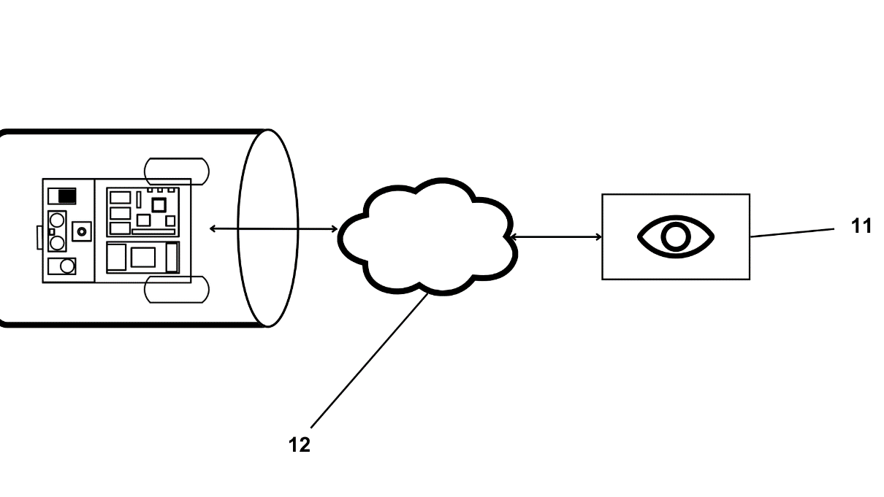
Figure 5

SVKM’s Dwarkadas J. Sanghvi College of Engineering
Applicant

